**Group Members**

Thanh Le, 015062801, [thanh.le0](mailto:thanh.le01@cc.peralta.edu)1@sjsu.edu

Andreah Cruz, 013468910, andreah.cruz@sjsu.edu

Kai Qi Chee, 014198730, kaiqi.chee@sjsu.edu

Shiyun Lian, shiyun.lian@sjsu.edu

Christopher McCain, 011277877, christopher.mccain@sjsu.edu

**Project Overview**

The purpose of the project is to build a web application platform where doctors can sign up and log in to access information from the hospital database. Our web application is called “Hospital Information System”, it can provide a fast and easy patient management system for the medical staff. Medical staff will be able to filter information about hospital patients, pharmacy, and appointments.

**Why “Hospital Information System”**

Not only will our application provide easy appointment lookups, but its user-friendly interface will provide a patient’s medical history, medical needs, and other personal information with the click of a button. With this, a doctor can easily get a brief summary of the patient before going into the appointment with them. We will use different queries to create and filter hospital information and return that requested information to the user.

**Query Functionality**

Doctors can use filter functions that will be executed as queries to check patient appointments as well as patient medical history. During the appointment, a doctor will be able to look up their patient’s name and know what kinds of medicines that their patient is using.

**Project Architecture**

Three-tier architecture

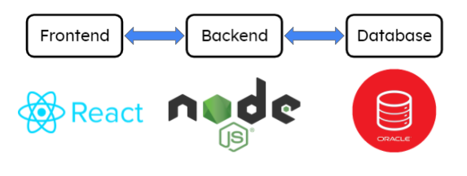

**Functional Requirements**

1. User log in:

When users successfully log in from the home page, they will be directed to a page where the patient's information will be displayed based on a particular user ID.

If users fail to log in, a message will pop up to let users know.

1. Create patient or appointment:

After users log in, they can create a patient record by clicking the ‘Create Patient’ button or create an appointment with the ‘Create Appointment’ button. After filling out all the necessary information, they can click the “Save” button to send the new record to the hospital database.

1. Edit patient information:

After users log in, they can edit patient information by selecting a particular patient.

1. Delete patient, doctor, or appointment information:

After users log in, they can delete patient/doctor/appointment information by selecting a particular patient/doctor/appointment to delete. This will delete all corresponding files and information.

1. Search patient based on ID, DOB or name:

After users log in, they can use the search bar to find a particular patient by ID/DOB/name. All relevant results will be displayed for the user

1. Search doctor based on ID, name, or type:

After users log in, they can use the search bar to find a particular doctor by ID/name/type. All relevant results will be displayed for the user

1. Search appointment based on ID, time, doctor, or patient:

After users log in, they can use the search bar to find a particular appointment by ID/time/doctor/patient. All relevant results will be displayed in descending order for the user

**Entities vs Attributes**

1. Hospital has a unique ID, name, and address
2. Doctor has a unique ID, name, and type of doctor
3. Patient has a unique ID, name, DOB, address, and medical history. Also, a patient has the upcoming appointment
4. Nurse has a unique ID, name, and type
5. Room has a unique room number and it includes total number of beds, and total available beds
6. Patient Files is a multi valued attribute to the entity patient
7. Pharmacy has a unique ID, address, and hours of operation
8. Medicine has a unique ID, name, and dosage
9. Bill has a unique ID and price
10. Appointment has a unique ID, Timestamp, Doctor, and Patient

**Project Requirements**

Modules

1. Login Pages
   1. Hospital ID
   2. Username
   3. Password
   4. Sign Up
2. Home Pages
   1. Doctor’s Patients
   2. Doctor’s Appointments
3. Patients
   1. Personal Information
   2. Patient ID
   3. Medical History
   4. Medical needs
   5. Appointments with specified doctor
   6. Prescriptions
   7. Medical Bill
   8. Images and Files
4. Pharmacy
   1. Pharmacy ID
   2. Medicines
   3. Quantity
   4. Price